ftele
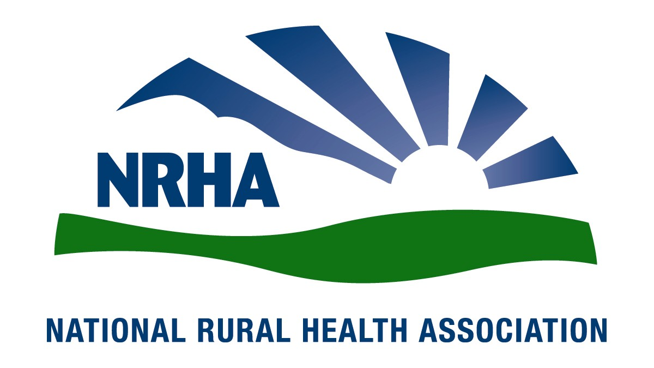
Government Affairs Office
1025 Vermont Street NW
Suite 1100
Washington, D.C. 20005
202-639-0550
Fax: 202-639-0559
Headquarters
4501 College Blvd, #225
Leawood, KS 66211-1921
816-756-3140
Fax: 816-756-3144

March 4, 2019

The Honorable Rosa DeLauro  Chairman  Subcommittee on Labor, Health and Human Services, Education, and Related Agencies  U.S. House of Representatives  Washington, DC 20515 | The Honorable Tom Cole  Ranking Member  Subcommittee on Labor, Health and Human Services, Education, and Related Agencies  U.S. House of Representatives  Washington, DC 20515
The Honorable Sanford Bishop Jr.  Chairman  Subcommittee on Agriculture, Rural Development, Food and Drug Administration, and Related Agencies  U.S. House of Representatives  Washington, DC 20515 | The Honorable Jeff Fortenberry  Ranking Member  Subcommittee on Agriculture, Rural Development, Food and Drug Administration, and Related Agencies  U.S. House of Representatives  Washington, DC 20515
Dear Representatives DeLauro, Cole, Bishop, and Fortenberry,

On behalf of the National Rural Health Association (NRHA) we ask that you continue to support several critically important rural health programs as you move forward with the Fiscal Year 2020 funding measures. We thank you for your leadership and support for rural health programs and hope you will continue these important efforts.

NRHA is a national nonprofit membership organization with more than 21,000 members with a mission to provide leadership on rural health issues. NRHA membership consists of a diverse collection of individuals and organizations that share a common interest in ensuring all rural communities have access to quality, affordable health care.

We greatly appreciate the efforts of the Subcommittee on Labor, Health and Human Services, Education, and Related Agencies and applaud your leadership in supporting rural health programs. This letter outlines recommendations that we believe will strengthen the rural health care safety net while ensuring that rural Americans maintain their access to critical services.

While we understand the current federal budget situation, rural health discretionary spending is relatively small but is vitally important for maintaining access to care for individuals living in rural America. The rural healthy safety net programs outlined below are effective and crucial for the physical and economic health of many rural communities. Please continue to support these important programs that help in solidifying the fragile rural health care infrastructure in the United States.

Many vital discretionary programs help ensure the efficient and equitable delivery of health care services in rural areas. To better meet these needs, while simultaneously understanding the fiscal constraints demanded by Congress, the NRHA requests a modest, across-the-board funding increase of 10 percent (unless another amount has specifically been authorized by law).

These programs include: The Outreach Grant Program funds community-based projects for three years to increase access to care. Typical projects address diabetes, obesity, screening, adolescent health, oral health, and mental health. More than 2 million people have benefited and more than 85% of grant programs continue to deliver services five years after federal funding has ended.

Network Development Grants address the business and management challenges of working with underserved rural communities, including help to overcome the fragmentation of health care services in rural areas and to achieve economies of scale. The program provides funding to rural communities that are beginning to examine the benefits of building networks so they can initiate the process.

Rural Health Research/Policy funds the Federal Office of Rural Health Policy (FORHP). FORHP administers rural health programs, coordinates activities related to rural health care, and advises the Secretary on access to care, the viability of rural hospitals, and the availability of physicians and other health professionals.

State Offices of Rural Health, located in all 50 states, help rural communities build health care delivery systems by collecting and disseminating information, providing technical assistance, helping coordinate rural health state-wide, and by supporting efforts to improve recruitment and retention of health professionals.

Rural Hospital Flexibility Grants are used by each state to implement new technologies, strategies and plans in Critical Access Hospitals (CAH). CAHs provide essential services to a community. Their continued viability is critical for access to care and the health of the rural economy. Additional funding for the Rural Hospital Flexibility Grants in the 2018 Omnibus allowed for the Vulnerable Rural Hospitals Assistance Program. This program will fund one entity up to $800,000 to provide targeted, in-depth assistance to vulnerable rural hospitals struggling to maintain health care services. The awardee will work with individual hospitals and their communities on ways to understand community health needs and find ways to ensure hospitals and communities can keep needed care locally.

EMS Sustainability Grants are included under the Flexibility Grants program and build an evidence base for sustainable rural EMS model, and are essential in the changing landscape of rural EMS. These grant programs offer the opportunity to develop and implement projects to ensure continued access to EMS in rural America.

Rural Communities Opioids Response Programs provide funds to support treatment for and prevention of substance use disorder, focusing on rural communities with the highest risk for substance use disorders.

Telehealth funding is for the Office for the Advancement of Telehealth, including the Telehealth Network Grant Program, which promotes the effective use of technologies to improve access to health services and to provide distance education for health professionals.

Community Health Centers provide essential community care, including primary care, oral health, and mental health, as well as other necessary services to medically underserved areas. Robust funding is necessary for their continued growth and to ensure they can provide quality, affordable care.

National Health Service Corps supports qualified health care providers by providing scholarship and loan-repayment programs for those serving medically underserved communities and populations with health professional shortages and/or high unmet needs for health services.

Title VII and VIII programs, including Rural Physician Training Grants, Area Health Education Centers, and Geriatric programs, provide policy leadership and grant support for health professions workforce development for shortage areas.

The USDA's Rural Hospital Technical Assistance Program was created in 2018 using discretionary funding in the USDA's Office of Rural Development. The program will provide technical assistance to rural hospitals with USDA loans to ensure their continued viability and financial success. NRHA requests Congressional support, building upon language in the 2018 Farm Bill, to slowly and responsibly grow this program as it demonstrates success to expand technical assistance to struggling rural providers.

NRHA is grateful for your support in recognizing the need for providing a strong future for the delivery of rural health care. We hope you will continue to support the millions of Americans in rural and underserved areas by acknowledging and considering these funding priorities.

Sincerely,

Alan Morgan
Chief Executive Officer
National Rural Health Association

