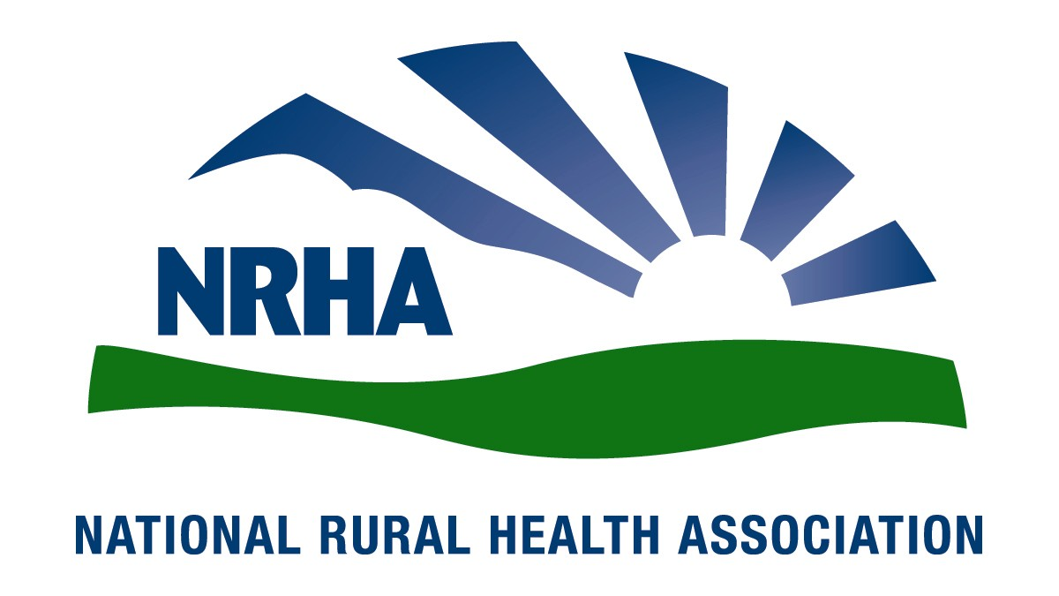
Government Affairs Office
1025 Vermont Avenue
Suite 1100
Washington, D.C. 20005
202-639-0550
Fax: 202-639-0559
Headquarters
4501 College Blvd, #225
Leawood, KS 66211-1921
816-756-3140
Fax: 816-756-3144

June 25, 2018

Seema Verma
Administrator
Centers for Medicare and Medicaid Services
Hubert H. Humphrey Building
200 Independence Avenue, SW, Room 445‐G
Washington, DC 20201

RE: Medicare Program; Hospital Inpatient Prospective Payment Systems for Acute
Care Hospitals and the Long-Term Care Hospital Prospective Payment System and
Proposed Policy Changes and Fiscal Year 2019 Rates; Proposed Quality Reporting
Requirements for Specific Providers; Proposed Medicare and Medicaid Electronic
Health Record (EHR) Incentive Programs (Promoting Interoperability Programs)
Requirements for Eligible Hospitals, Critical Access Hospitals, and Eligible
Professionals; Medicare Cost Reporting Requirements; and Physician Certification
and Recertification of Claims

Dear Administrator Verma,

The National Rural Health Association (NRHA) is pleased to offer comments on the CMS proposed rule for the Medicare Program; Hospital Inpatient Prospective Payment Systems for Acute Care Hospitals and the Long-Term Care Hospital Prospective Payment System and Proposed Policy Changes and Fiscal Year 2019 Rates; Proposed Quality Reporting Requirements for Specific Providers; Proposed Medicare and Medicaid Electronic Health Record (EHR) Incentive Programs (Promoting Interoperability Programs) Requirements for Eligible Hospitals, Critical Access Hospitals, and Eligible Professionals; Medicare Cost Reporting Requirements; and Physician Certification and Recertification of Claims. We appreciate your continued commitment to the needs of the 62 million Americans residing in rural areas, and look forward to our continued collaboration to improve health care access and quality throughout rural America.
NRHA is a non-profit membership organization with more than 21,000 members nationwide that provides leadership on rural health issues. Our membership includes nearly every component of rural America’s health care, including rural community hospitals, critical access hospitals, doctors, nurses and patients. We work to improve rural America’s health needs through government advocacy, communications, education and research.

NRHA supports the Low-Volume Adjustment changes included as a result of the Bipartisan Budget Deal of 2018.
There is, however, a typo included in the narrative description of the change on page 20385 of the Federal Register. This erroneously indicates the formula to be [(95/330)X(Discharges/13,200)], the correct formula is included in the regulatory section below at page 20567 as [(95/330)-(Discharges/13,200)].
NRHA urges CMS to clarify that the total discharges are only for those adult and pediatric units subject to the IPPS and does not include discharges from psychiatric, rehabilitation or skilled nursing units not subject to the IPPS. The proposed regulation wording at 42 CFR 412.101(b)(2)(iii) just describes eligibility for FY 2019 through FY 2022 as being for hospitals with “…fewer than 3,800 total discharges, which includes Medicare and non-Medicare discharges,” without clarifying the total discharges are only for adults and pediatrics units subject to the IPPS. Indeed, simply identifying the specific source of this data (Worksheet S-3, Part 1, Column 15, Line 1) would remove all ambiguity. Furthermore, additional ambiguity would be eliminated on discharge count by specifying the year referenced “…based on the hospital’s most recently submitted cost report,” without specifying if the most recent cost report is submitted as of publication of the proposed rule, publication of the final rule, or some other date? While NRHA is agnostic as to the selected date, we urge a clear delineation to allow hospitals to properly plan.

NRHA supports the change of the applicable effective date for hospitals seeking Medicare Dependent Hospital (MDH) and Sole Community Hospital (SCH) status. CMS proposes changing the applicable effective date for hospitals seeking MDH status. Under current rules, a hospital qualifying to be classified as an MDH begins receiving a payment adjustment 30 days after the date of CMS’ approval of the classification. CMS proposes to change the effective date to 30 days from the date CMS receives the completed application. NRHA seeks a clarification of the proposal which references “the date CMS receives the complete application…”. While, the urban to rural election at 412.103(b)(3) requires the hospital to submit the application to the CMS Regional Office; the comparable SCH and MDH regulations at 412.92(b)(1)(i) and 412.108(b)(2) require those applications to go to the MAC. So, it would be preferable in both of the new sections for CMS to say the SCH & MDH status is effective as of “the date the MAC receives the complete application” or at least clarify in the narrative that receipt by the MAC is deemed to be receipt by CMS.

NRHA supports the goal of interoperability and data sharing with patients. However, the burden should be on the software companies not the small rural hospitals since only the software companies have the power to comply with these regulations. Rural hospitals have attempted to made prudent choices in EHR products, however, many have found themselves needing to purchase new products when the vendor selected to not upgrade the product. Leaving some hospitals to have to take the time and expense of setting up and training staff on multiple software programs. Further complicating the use and upgrades required, many rural communities do not have a sufficient IT workforce. Therefore, NRHA applauds the continued flexibility provided while continuing to move towards the laudable goal of interoperability and urges CMS to consider additional hardship exemptions for small rural providers that find themselves unable to upgrade due to vendor decisions.

NRHA is vociferously opposed to adding interoperability requirements to the Conditions of Participation (COP). While we strongly support the goals of interoperability and encourage CMS to continue the trajectory towards interoperability we continue to encourage the onus to be placed on the vendors producing the products and not the hospitals simply purchasing the products that are available. While vendor changes can cause issues for rural hospitals currently resulting in an additional cost or the loss of revenue in the form of penalties, however, the implications of failing to meet a COP and losing the ability to treat Medicare patients would be catastrophic for a rural hospital and its community. Additionally, the notice and comment rulemaking process provides an important feedback loop that can lead to less unnecessary red tape and allows for stakeholder feedback and input of practical real-world implications of regulatory changes. Rural hospitals are often negatively impacted by the unintended consequences of generally applicable rules, the notice and comment rulemaking process is an important check on these unintended consequences. We believe this process of notice and comment rulemaking will lead to a regulatory scheme that achieves the goals of interoperability without undue and unnecessary burdens, a goal we share with this administration. Finally, we are concerned that placing interoperability requirements in the COP makes any violation, including inadvertent or mistakes, potentially catastrophic to a rural communities’ ability to access necessary local care.

NRHA supports the inclusion of sociodemographic risk in the Hospital Readmission Reduction Program (HRRP), however, we continue to urge adoption of a more suitable measure of sociodemographic risk since Medicaid rate is not a sufficient proxy. It is essential that providers not be penalized for factors outside of their control, especially when providing care for vulnerable patient populations. Such penalties will serve to further erode the rural health care safety net already feeling the strain from repeated Medicare reimbursement cuts that MedPAC continues to report make reimbursement rates on average below the cost of providing care. Rural patients are on average older, sicker, and poorer than their urban counterparts with higher rates of chronic disease and higher rates of lifestyle choices detrimental to health, such as tobacco use and opioid addiction. Numerous studies have demonstrated that rural providers deliver excellent high-quality care, however, these patient factors have been well documented to impact patient outcomes even when the care provided exceeds standards of care. It is essential that providers that are willing to provide care to this type of vulnerable patient population not be penalized for outcomes that are outside of their control and that do not reflect the care provided.
While we recognize that dual eligibility is an easy metric to identify and does provide some useful information about the patient population it is not itself sufficient to identify sociodemographic risk. A 2017 Center for Disease Control (CDC) study found that “[t]he death rate gap between urban and rural America is getting wider” as a result of the fact that the rate of the five leading causes of death- heart disease, cancer, unintentional injury, chronic respiratory disease, and stroke – are all higher amount rural patients. Additionally, risky lifestyles, environmental factors, and mental health issues leading to suicides, negatively impact rural life expectancy. A plethora of other studies demonstrate similar indications of sociodemographic risk. These factors are not fully accounted for by the disparity between rural and urban Medicaid rates (21% rural vs. 16% urban).

NRHA is concerned about the “codified policies regarding multi-campus hospitals.” While this proposal is presented as a codification it is a change in longstanding CMS policy, which is tacitly recognized in the proposal where it is stated that “current MDHs and SCHs should make sure this proposal does not create a change in circumstances.” While we recognize the administrative issues cited CMS has long been treating multi-campus facilities as distinct entities for a variety of purposes. We believe this policy could result in a loss of access to care in rural America in two ways, first for those that are contemplating serving rural communities the inability to access the programs and designations Congressionally created to ensure rural access to care and for those currently serving rural communities the loss of access to those same Congressionally created rural programs will result in not only the closure of a single location but potentially of the entire hospitals, including all locations. While we are concerned we also request clarification of the proposal to assuage concerns about the intended scope of this policy. First, the policy focuses on bed counts but does not specifically indicate the impact on mileage, would the same standard be applied when determining distance between facilities, even facilities without inpatient beds? Furthermore, this policy does not indicate any application to Critical Access Hospitals (CAHs), and we seek clarification to confirm such an application is not intended. Second, we seek clarification about what is required of the multi-campus remote location to be included in this policy change as not all campuses are equal. Such an extension would be particularly concerning when examining remote locations without 24/7 Emergency care, since this would allow a small remote clinic with limited hours and providers to result in loss of access to life saving emergency care. We believe loss of access would clearly be an unintended consequence of an attempted simplification of the administrative burden on CMS and wish to work with CMS to clarify the policy to ensure rural Americans continue to have access to necessary local care. While NRHA supports the efforts undertaken by this administration, we also appreciate this opportunity to comment and work with CMS to stop any unintended consequences. NRHA believes the examination of these potential consequences through the rural lens, outlined in the recently released CMS Rural Health Strategy, highlights how these unintended consequences would negatively impact vulnerable patients and communities.

NRHA is concerned about the trend that budget neutral adjustments to reconcile MS-DRG changes are disproportionately disadvantaging rural hospitals. While each of the annual updates have been seemingly small reductions for rural providers, for example for FY2019 CMS estimates the adjustment will cause a 0.3 percent payment reduction for rural hospitals while resulting in a positive update of 0.1 percent for urban providers, the overall additive impacts are growing for rural hospitals, for example for SCHs this amounts to about 2.5 percent cut over the past 8 years, growing disparities in the gap between rural and urban hospitals. While we recognize that the case mix at rural hospitals coupled with the weighting changes is the ultimate cause of this disparity, the basic case mix differential is well known and therefore the impact is predictable. We believe this should be examined using a rural lens to identify the unintended negative impacts on vulnerable rural communities and patients, per the CMS Rural Health Strategy. Under Section 1886(d)(5)(I)(i) of the Social Security Act, which allows “other exceptions and adjustments to such payment amounts under this subsection as the Secretary deems appropriate.” This authority has been previously used by CMS when the MS-DRGs were implemented. This flexibility could be utilized to reevaluate the size of the documentation and coding cuts of rural hospitals to recalibrate overall reimbursement to allow small rural hospitals to remain open and serving their communities.

NRHA supports the Hospital-Acquired Condition (HAC) Reduction Program included in the Affordable Care Act, however, we are concerned that penalties may ultimately harm the ability of low margin providers to make the necessary improvements leading to a further erosion of access to care to vulnerable patient populations. NRHA is supportive of quality programs and the inclusion of rural providers in these programs, however, it is essential that these programs do not include penalties that ultimately lead to hospitals serving vulnerable populations with thin or negative profit margins losing the ability to continue to provide care to the vulnerable patient population they serve. For providers providing access to care that is essential to their communities, CMS must consider the impact on the ability of these provides to continue to provide this access and on methods to actually spur change in these facilities already lacking the resources necessary for improvement activities.

NRHA is opposed to the application of the national rural floor for the wage index. As noted in the rule, only urban hospitals can benefit from this change. As of last year, 44 percent of rural hospitals were operating at a loss, up from 40 percent the year before with no indications this trajectory has changed. Since 2010, 85 rural hospitals have closed with two occurring within a week of this writing. Rural communities are greatly affected by the maldistribution of healthcare professionals. Indeed, the Robert Wood Johnson Foundation found that maldistribution was a much larger problem than an absolute shortage of primary care providers. One aspect of this maldistribution is the fact that urban facilities offer better salaries and benefits, plus the additional benefits of greater peer support from a larger workforce. Economic forces would indicate that paying higher, not the lower rates already provided for under the wage index, is the appropriate response to workforce maldistribution. This move to further erode the rural wage index will exacerbate instead of alleviating the maldistribution problem. Basic economic principles indicate the rural wage index should exceed that of the urban areas without shortages, instead of a low index based on the cost of living. NRHA urges CMS to reconsider the wage index as a tool to reduce maldistribution of health care providers instead of just attempting to focus on the spending power of that money. While we recognize the concerns raised on the state based application of the floor, we believe the solution should protect rural hospitals, the clear intended beneficiaries of the rural floor.

Thank you for the chance to offer comments on this proposed rule, and for your consideration on our comments. We very much look forward to continuing our work together to ensure our mutual goal of improving quality of and access to care. If you would like additional information, please contact Diane Calmus at dcalmus@nrharural.org, or 202-639-0550.

Sincerely,
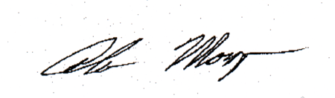

Alan Morgan
Chief Executive Officer
National Rural Health Association

