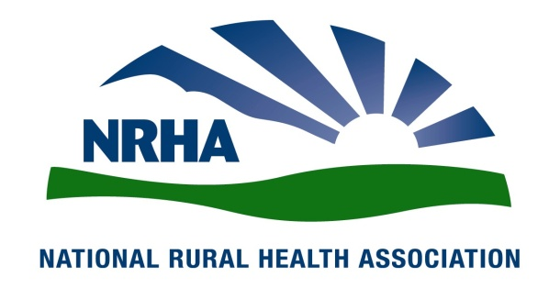

Rural Hospital Closures
Decimating Rural Health Care Delivery

Overview:
Since 2010, seventy-nine rural hospitals have closed. In fact, the rate of closure has steadily increased since sequesters and bad debt cuts began to hit rural hospitals. The rate of closures is five times higher in 2016 compared to 2010. Right now, 673 additional facilities are vulnerable and could close, representing more than one-third of rural hospitals in the U.S. Continued cuts in hospital payments have taken their toll, forcing far too many closures and leaving many of our nation’s most vulnerable populations without timely access to care
When a rural hospital closes … rural patients suffer:
“An 18-month-old Texas child with a grape lodged in her throat died in her desperate parents’ arms because the county’s only hospital and emergency room had closed for good a few months earlier.”
“Four days after a North Carolina hospital closed, a 48-year-old woman suffered a heart attack and died just as the helicopter arrived to airlift her to the next nearest hospital, now 75 miles away.”
- If Congress allows 673 vulnerable rural hospitals to close, 11.7 million patients will lose direct access to care.
- 640 counties across the country are without quick access to an acute-care hospital.
- 77 percent of the nation’s 2,041 rural counties are health professional shortage areas.
- More than 40 percent of rural patients have to travel 20-plus miles to receive specialty care, compared to 3 percent of metropolitan patients.
- 60 percent of trauma deaths occur in rural America, even though only 20 percent of Americans live in rural areas.
- Rural Americans are more likely to die from the 5 leading causes of death (heart disease, cancer, chronic lower respiratory disease, accidents, and stroke) than their urban counterparts, in part due to lacking access to hospital services.
- Unintentional injury deaths are 50% higher in rural areas than in urban areas.

When a rural hospital closes … the rural economy suffers:
- In rural America, the hospital is often one of the largest employers in the community. Health care in rural areas can represent up to 20 percent of the community’s employment and income.
- The average critical access hospital creates 170 jobs and generates $7.1 million in salaries, wages, and benefits annually.
- If a rural provider is forced to close, the community erodes.
- The recession in rural America continues, with 90 percent of all job growth since 2008 occurring in metropolitan areas. If a hospital closes in a rural community, health providers relocate, and the town withers.
- If Congress allows 673 additional hospitals to shut their doors, 99,000 direct health care jobs and another 137,000 community jobs will vanish. Over 10 years, rural communities will lose $277 billion in GDP.
When a rural hospital closes … the taxpayer suffers:
- Rural hospitals provide cost-effective primary care. It is 2.5 percent less expensive to provide identical Medicare services in a rural setting than in an urban or suburban setting. This focus on primary care, as opposed to specialty care, saves Medicare $1.5 billion/year. Quality performance measurements in rural areas are on par with if not superior to urban facilities.
- Federal Medicare dollars spent on critical access hospitals: CAHs represent nearly 30 percent of acute care hospitals but receive less than 5 percent of total Medicare payments.

What can Congress do to prevent rural hospital closures?
Stop the bleeding – support the Save Rural Hospitals Act.

- In just a few years, rural hospitals have received tens of millions in Medicare reductions (loss of rural hospitals designations and payments, sequestration cuts, and ACA cuts).
- The President, HHS Office of Inspector General, CBO and MedPAC have called for additional Medicare cuts to rural providers.
- The presidential budget planned to strip millions of dollars from the rural safety net.
- Additionally, the lack of Medicaid expansion in the poorest rural states has led to significant lost revenue due to cuts in the ACA, forcing many rural hospitals to close. Potential future cuts to Medicaid heighten the impending fear of closure.

