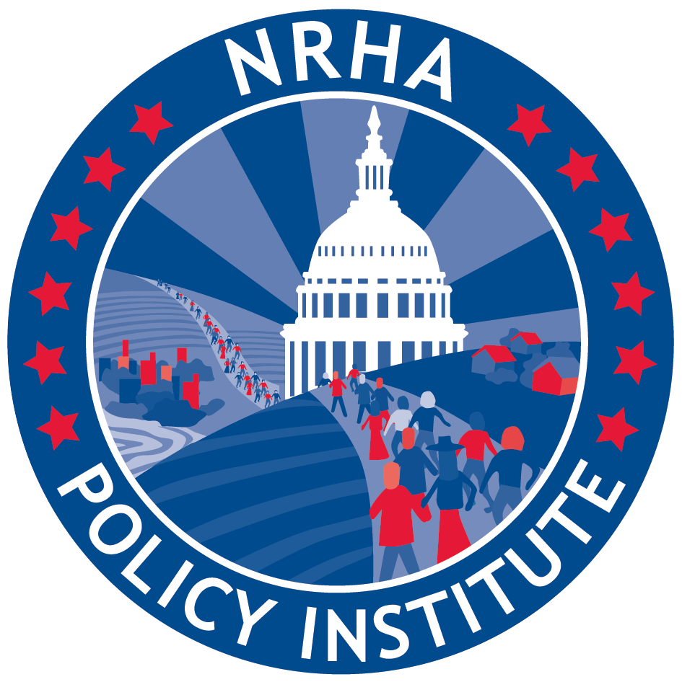
Sponsor the Save Rural Hospitals Act (H.R. 2957)
Rural hospitals are closing. Seventy-nine rural hospitals have closed since 2010. Right now, 673 additional facilities are vulnerable and could close—this represents over 1/3 of rural hospitals in the U.S. In fact, the rate of closure has steadily increased since sequester and bad debt cuts began to hit rural hospitals; resulting in a rate five times higher in 2016 compared to 2010. Continued cuts in hospital payments have taken their toll, forcing far too many closures. Medical deserts are appearing across rural America, leaving many of our nation’s most vulnerable populations without timely access to care.
Rural patients are vulnerable. Rural Medicare beneficiaries already face a number of challenges when trying to access health care services close to home. Seventy-seven percent of rural counties in the United States are Primary Care Health Professional Shortage Areas while nine percent have no physicians at all. Rural seniors are forced to travel significant distances for care, especially specialty services. Additionally, rural populations as a whole are more likely to be underinsured or uninsured, be poorer than their urban counterparts, and experience more chronic disease.

Local emergency medical care matters. On average, rural trauma victims must travel twice as far as urban residents to the closest hospital. In an emergency every second counts! As a result of these disparities, 60% of trauma deaths occur in rural America, even though only 20% of Americans living in rural areas. But the situation is poised to get even worse. If the 673 vulnerable hospitals closed, rural patients would need to seek alternatives for 11.7 million hospitals visits, 99,000 health care workers would need to find new jobs, and $277 billion in GPD would be lost.

The solution is legislation. The Save Rural Hospitals Act will stop the impending flood of rural hospital closures and provide needed access to care for rural America. Additionally, it will create an innovative delivery model that will ensure emergency access to care for rural patients across the nation.

- Rural hospital stabilization
  - Elimination of Medicare Sequestration for rural hospitals (CAH, SCH, MDH, and subsection (d) facilities in rural census tracks and non-MSA counties);
  - Reversal of “bad debt” reimbursement cuts (The Middle Class Tax Relief and Job Creation Act of 2012);
  - Permanent extension of current Low-Volume and Medicare Dependent Hospital payment levels;
  - Reinstatement of Sole Community Hospital “Hold Harmless” payments;
  - Extension of Medicaid primary care payments;
  - Elimination of Medicare and Medicaid DSH payment reductions;
  - Establishment of Meaningful Use support payments for rural facilities struggling to maintain MU compliance; and
  - Permanent extension of the rural ambulance and super-rural ambulance payment.

- Rural Medicare beneficiary equity
Equalize patient copayments for outpatient services at CAHs with copays at other hospitals.

- Regulatory relief
  - Elimination of the CAH 96-Hour Condition of Payment;
  - Rebase of supervision requirements for outpatient therapy services at CAHs and rural PPS facilities; and
  - Modification to 2-Midnight Rule and RAC audit and appeals process.

- Future of rural health care
The innovative future model solution, created by the Save Rural Hospitals Act, establishes a new Medicare payment designation, the Community Outpatient Hospital (COH). This model will ensure access to emergency care and allow hospitals the choice to offer outpatient care that meets the population health needs of their rural community.
- Eligibility: Critical Access Hospitals (CAH) and rural hospitals with 50 beds or less as of December 31, 2014 are eligible to become COH (this includes facilities as described that have closed within 5 years prior to enactment).
- Services:
  - Emergency Services – a COH must
    - Provide emergency medical care and observation care (not to exceed an annual average of 24 hours), 24 hours a day, 7 days a week.
    - Have protocols in place for the timely transfer of patients who require a higher level of care or inpatient admission.
  - Meeting the Needs of Rural Communities. Based upon a community needs assessment, a COH could provide medical services in addition to the Emergency services, but not limited to observation care, skilled nursing facility (SNF) care, infusion services, hemodialysis, home health, hospice, nursing home care, population health and telemedicine services.
    - COHs are encouraged to provide primary care services though a FQHC (or FQHC look alike) or rural health clinic. These primary care services will ensure the community don’t lose primary care and inappropriately use the emergency room.
    - The COH will not operate any inpatient acute care beds, but can operate swing beds and observation beds.
- Payments: The Medicare payment rate for services furnished at a COH (emergency care and outpatient services) will be 105% of reasonable cost. Plus, wrap around grants for population health to ensure sufficient payments to allow the COH to serve the needs of the community.
- Conversion:
  - For every CAH that converts to a COH, another hospital currently not designated as a CAH and located in the same state, would be eligible to become a CAH so long as all criteria other than the distance criteria are met.
  - CAHs that convert to COHs may revert back to the CAH designation at any time and under the same conditions they were originally designated.
- Rural Hospital Grants: New grants are included for Rural EMS. Hospital based grants are available to assist rural hospitals with the change to value based payment models and for rural hospitals working on population health (included a grant program targeted at COHs).

