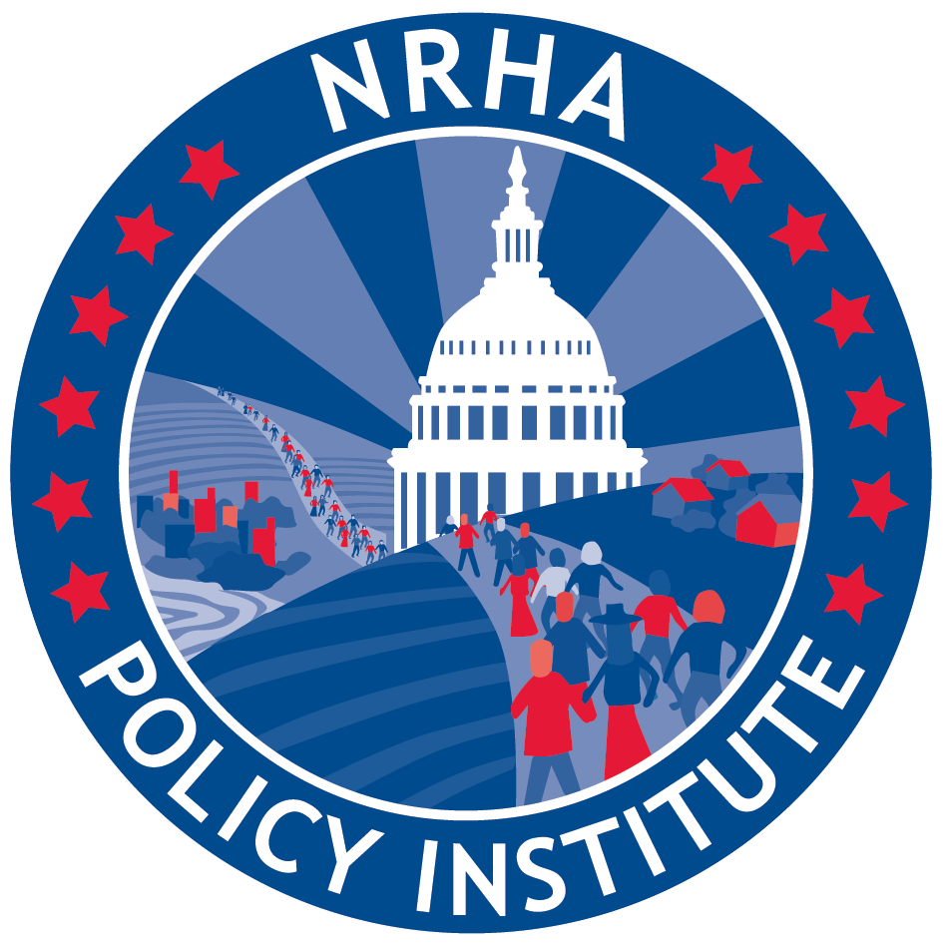Sponsor the Save Rural Hospitals Act
Rural hospitals are closing. Seventy-eight rural hospitals have closed since 2010. Right now, 673 additional facilities are vulnerable and could close—this represents over 1/3 of rural hospitals in the U.S. In fact, the rate of closure has steadily increased since sequester and bad debt cuts began to hit rural hospitals; resulting in a rate six times higher in 2015 compared to 2010. Continued cuts in hospital payments have taken their toll, forcing far too many closures. Medical deserts are appearing across rural America, leaving many of our nation’s most vulnerable populations without timely access to care.
Rural patients are vulnerable. Rural Medicare beneficiaries already face a number of challenges when trying to access health care services close to home. Seventy-seven percent of rural counties in the United States are Primary Care Health Professional Shortage Areas while nine percent have no physicians at all. Rural seniors are forced to travel significant distances for care, especially specialty services. Additionally, rural populations as a whole are more likely to be underinsured or uninsured, be poorer than their urban counterparts, and experience more chronic disease.

Rural health care is cost-effective care. Critical Access Hospitals make up nearly 30% of acute care hospitals, but receive less than 5% of total Medicare payments to hospitals. CMS actually spends 2.5% less on rural beneficiaries than it does on urban beneficiaries. Additionally, rural health care can represent as much as 20 percent of the local salaries, wages, and benefits, and are often one of the two largest employers in their counties. (The average Critical Access Hospital alone creates 195 jobs and generates $8.4 million in payroll annually.)

The solution is legislation. The Save Rural Hospitals Act will stop the impending flood of rural hospital closures and provide needed access to care for rural America. Additionally, it will create an innovative delivery model that will ensure emergency access to care for rural patients across the nation. The goals of the Act are to provide:

- Rural hospital stabilization
  - Elimination of Medicare Sequestration for rural hospitals (CAH, SCH, MDH, and subsection (d) facilities in rural census tracks and non-MSA counties);
  - Reversal of “bad debt” reimbursement cuts (The Middle Class Tax Relief and Job Creation Act of 2012);
  - Permanent extension of current Low-Volume and Medicare Dependent Hospital payment levels;
  - Reinstatement of Sole Community Hospital “Hold Harmless” payments;
  - Extension of Medicaid primary care payments;
  - Elimination of Medicare and Medicaid DSH payment reductions;
  - Establishment of Meaningful Use support payments for rural facilities struggling to maintain MU compliance; and
  - Permanent extension of the rural ambulance and super-rural ambulance payment.

- Rural Medicare beneficiary equity
Unlike other hospitals, copayments for outpatient services at a CAH are calculated on total charges not on the allowed Medicare charge which results in unfair higher out-of-pocket costs for rural patients.

- Regulatory relief
  - Elimination of the CAH 96-Hour Condition of Payment (See Critical Access Hospital Relief Act of 2015);
  - Rebase of supervision requirements for outpatient therapy services at CAHs and rural PPS facilities (See PARTS Act); and
  - Modification to 2-Midnight Rule and RAC audit and appeals process.

- Future of rural health care
The Act will also provide an innovation model for rural hospitals who continue to struggle. This model will ensure access to emergency care and allow hospitals the choice to offer outpatient care that meets the population health needs of their rural community.

