Z
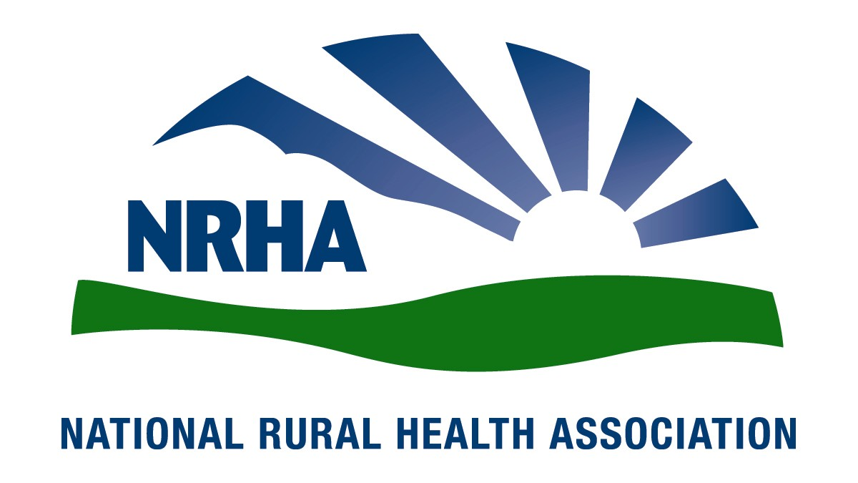
Government Affairs Office
1025 Vermont Ave NW
Suite 1100
Washington, D.C. 20005
202-639-0550
Fax: 202-639-0559
Headquarters
4501 College Blvd, #225
Leawood, KS 66211
816-756-3140
Fax: 816-756-3144

July 27, 2016

Andy Slavitt
Acting Administrator
Centers for Medicare and Medicaid Services
Hubert H. Humphrey Building
200 Independence Avenue, SW, Room 445‐G
Washington, DC 20201

Re: Medicare and Medicaid Programs; Hospital and Critical Access Hospital (CAH) Changes to Promote Innovation, Flexibility, and Improvement in Patient Care

Dear Administrator Slavitt:

The National Rural Health Association (NRHA) is pleased to respond to the Medicare and Medicaid Programs; Hospital and Critical Access Hospital (CAH) Changes to Promote Innovation, Flexibility, and Improvement in Patient Care proposed rule. We appreciate your continued commitment to the needs of the 62 million Americans residing in rural and underserved areas, and look forward to our continued collaboration to improve health care access and quality.

The National Rural Health Association (NRHA) is a non-profit membership organization with more than 21,000 members nation-wide that provides leadership on rural health issues. Our membership includes nearly every component of rural America’s health care infrastructure, including rural community hospitals, critical access hospitals, doctors, nurses and patients. We work to improve rural America’s health needs through government advocacy, communications, education and research.

Overall NRHA is supported of the changes proposed and the goals of those changes, however, we are concerned that the rule dramatically underestimates the time and effort required for compliance with the antibiotic stewardship and Quality Assessment and Performance Improvement (QAPI) programs. The administrators, doctors and nurses at these facilities are often called upon to fulfill a broad array of tasks to keep the hospital running, and these non-TJC accredited hospitals are unlikely to have staff with experience and expertise in developing this type of procedures, meaning not only is staff pulled away from other duties but they are also likely to take longer than an individual with experience in developing policies and procedures in this areas. Therefore, we request an additional year to comply with the new regulations relating to antibiotic stewardship and Quality Assessment and Performance Improvement (QAPI) programs for facilities that are not The Joint Commission (TJC) accredited. Furthermore, we recommend technical assistance be available through the flex grant program for those facilities that will need to update policies and procedures pursuant to this proposed rule. We believe these minor changes will allow this proposed rule to achieve its goal without unduly disrupting health care in these essential facilities that serve vulnerable rural Americans.

Thank you for the chance to offer a response on Medicare and Medicaid Hospital and Critical Access Hospital (CAH) Changes to Promote Innovation, Flexibility, and Improvement in Patient Care. We very much look forward to continuing our work together to ensure our mutual goal of improving quality of and access to necessary care in rural America. If you would like additional information, please contact Diane Calmus at dcalmus@nrharural.org, or 202-639-0550.

Sincerely,
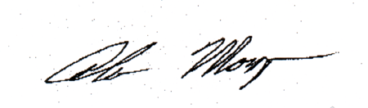

Alan Morgan
Chief Executive Officer
National Rural Health Association

