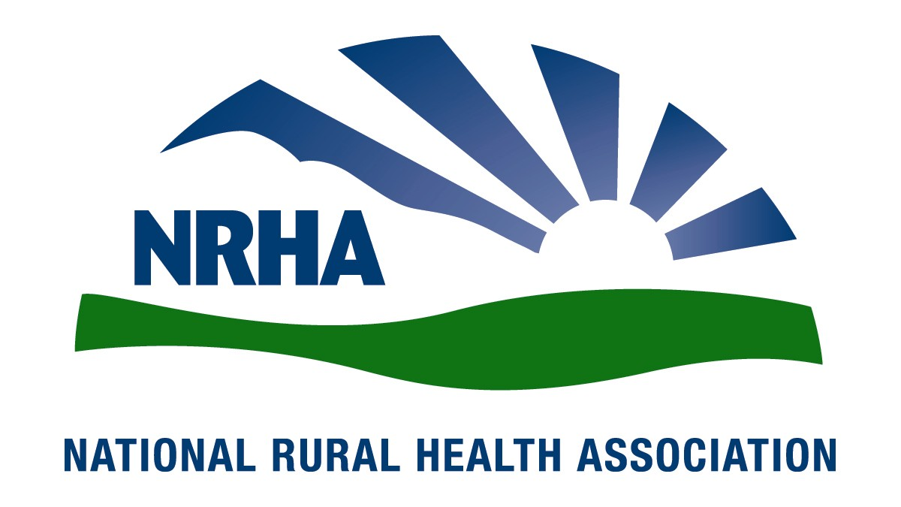
Government Affairs Office
1025 Vermont Avenue
Suite 1100
Washington, D.C. 20005
202-639-0550
Fax: 202-639-0559
Headquarters
4501 College Blvd, #225
Leawood, KS 66211-1921
816-756-3140
Fax: 816-756-3144

June 17, 2016

Andy Slavitt
Acting Administrator
Centers for Medicare and Medicaid Services
Hubert H. Humphrey Building
200 Independence Avenue, SW, Room 445‐G
Washington, DC 20201

RE: Medicare Program; Hospital Inpatient Prospective Payment Systems for Acute Care Hospitals and the Long-Term Care Hospital Prospective Payment System and Proposed Policy Changes and Fiscal Year 2017 Rates; Quality Reporting Requirements for Specific Providers; Graduate Medical Education; Hospital Notification Procedures Applicable to Beneficiaries Receiving Observation Services; and Technical Changes Relating to Costs to Organizations and Medicare Cost Reports

Dear Administrator Slavitt,

The National Rural Health Association (NRHA) is pleased to offer comments on the CMS proposed rule for the Hospital Inpatient Prospective Payment Systems for Acute Care Hospitals and the Long-Term Care Hospital Prospective Payment System and Proposed Policy Changes and Fiscal Year 2017 Rates; Quality Reporting Requirements for Specific Providers; Graduate Medical Education; Hospital Notification Procedures Applicable to Beneficiaries Receiving Observation Services; and Technical Changes Relating to Costs to Organizations and Medicare Cost Reports. We appreciate your continued commitment to the needs of the 62 million Americans residing in rural areas, and look forward to our continued collaboration to improve health care access and quality throughout rural America.
NRHA is a non-profit membership organization with more than 21,000 members nationwide that provides leadership on rural health issues. Our membership includes nearly every component of rural America’s health care infrastructure, including rural community hospitals, critical access hospitals, doctors, nurses and patients. We work to improve rural America’s health needs through government advocacy, communications, education and research.
NRHA is concerned the effective date for the MOON requirement does not provide hospitals sufficient time to create policies and procedure to implement the program. NRHA supports the standardized Medicare Outpatient Observation Notice (MOON) required under the NOTICE Act; however, we believe enforcing the effective day of August 6, 2016 will not allow hospitals sufficient time to develop the infrastructure required by this regulation. NRHA believes the effective date should be postponed until 90 days after finalization of this rule or the dissemination of the standardized MOON form, whichever is later. This delay is essential to allow for compliance.
NRHA is concerned with the changed proposed for Graduate Medical Eductation (GME) Rural Training Tracks (RTTs). Our comments below originate from a strong belief that the primary health needs of rural America are not being met. Of particular note, the production of primary care physicians, especially family physicians, is a key area where we believe the Centers for Medicare and Medicaid Services (CMS) can and should do more to remove barriers to increased production. We hope CMS will take to heart its authority to provide special consideration for underserved rural areas and will revise this proposal and construct regulations that enhance institutions’ ability to produce physicians who will practice in rural areas and serve underserved rural populations.
Changes made in the FY 2015 IPPS/LTCH PPS final rule (79 FR 50111) changed the time-period for growth of residency programs to the establishment of the institution’s Full Time Equivalent (FTE) cap from three to five years, to allow sufficient time for programs to grow to completion. The FTE cap for new residency programs in rural hospitals applies to the cost reporting period that coincides with or follows the start of the sixth program year of each new program started for rural hospitals. The same FTE limitation applies to cap setting in new urban teaching hospitals. CMS states in this proposed rule that when they implemented those changes, they inadvertently neglected to also change the growth window and effective date of FTE limitations for rural training tracks which are still set at 3 years; this proposed rule would apply the same changes to rural training tracks and remove that discrepancy.
We support the effort by CMS to extend the time period allowed for growth under the cap-setting limitations of rural training track programs. CMS recognizes the concerns expressed that rural training tracks, like any program, should have a sufficient amount of time for a hospital to “grow” and to establish a rural track FTE limitation that reflects the number of FTE residents that it will actually train, once the program is fully grown. We appreciate CMS’s recognition that there are times and circumstances that require amendment of its regulations in the interests of promoting sound public policy when interpreting and implementing the Medicare statute, and support the following consideration of its policies.
As part of that extension of time for the cap-setting period for RTTs the proposal goes on to state that “due to the statutory language at sections 1886(d)(5)(B) and 1886(h)(4)(H)(iv) of the Act as implemented in our regulations at §§ 412.105(f)(1)(v)(F) and 413.79(d)(7), except for new rural track programs begun by urban teaching hospitals that are establishing an FTE cap for the first time, FTE residents in a rural track training program at the urban hospital are subject immediately to the 3-year rolling average for direct GME and IME. In other words, unless the hospital is a brand new teaching hospital, the three-year rolling average will continue to apply to resident FTEs training in the rural track program, even during the five-year RTT cap-building window. The impact of the application of the rolling average to new RTTs is extremely detrimental to institutions’ ability establish new RTTs.
It is our belief that CMS’s continued reliance on only portions of the statute and their own regulations, which can be amended, rather than utilizing other portions of the statute that give more authority to support the concerns of rural areas is extremely problematic and detrimental to increasing the rural physician workforce.
For example, Section 1186(d)(5)(B)(v) refers back to section 1886(h)(4)(H)(iv) which states the following: Nonrural hospitals operating training programs in rural areas.—In the case of a hospital that is not located in a rural area but establishes separately accredited approved medical residency training programs (or rural tracks) in an rural area or has an accredited training program with an integrated rural track, the Secretary shall adjust the limitation under subparagraph (F) in an appropriate manner [emphasis added] insofar as it applies to such programs in such rural areas in order to encourage the training of physicians in rural areas.

In addition, other statutory language relating to new facilities states the following: `(i) NEW FACILITIES- The Secretary shall, consistent with the principles [emphasis added] of subparagraphs (F) and (G), prescribe rules for the application of such subparagraphs in the case of medical residency training programs established on or after January 1, 1995. In promulgating such rules for purposes of subparagraph (F), the Secretary shall give special consideration to facilities that meet the needs of underserved rural areas.”
For the purpose of providing adjustments to the limitations for hospitals establishing residency training programs in rural areas and giving special consideration for new facilities, CMS should include in its regulations relief in its regulations regarding the imposition of the rolling average at the inception of the RTT. We believe that the special consideration for new facilities should apply because the new program will be situated in a new facility – a new training site – and not in the urban “mother” hospital. Basically the effect of this rule is that urban hospitals will lose one complete years’ worth of claims for RTT FTEs. That loss will be spread over 2-4 years, but will be a net loss. The hospital will have to absorb these early losses. Below is a spreadsheet showing the impact of this loss on the various scenarios available.

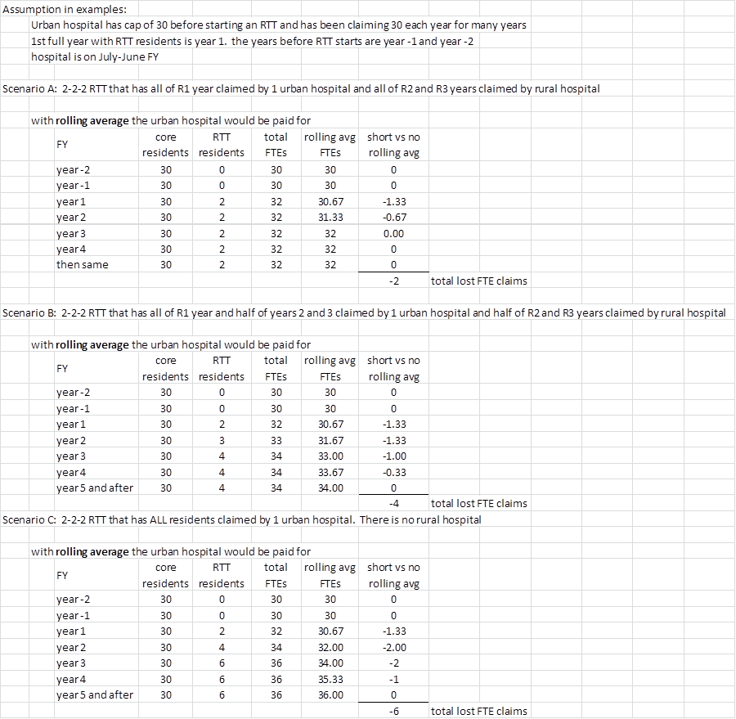
The Balanced Budget Act of 1997 established the concept that an urban hospital would be able to increase its cap on residency positions in order to accommodate residents training in rural areas as part of a rural training track (RTT) after the first year of training. The purpose was to allow the residents to obtain enough inpatient training at the urban hospital serving a larger and broader patient population in the first year, and then train in rural, community-based settings for the rest of the residency. Rural training track (RTT) residency programs are a proven model for addressing rural physician workforce shortages, with over 70% of graduates practicing in rural areas. Most RTTs still do not receive full GME funding for the rural portion of their programs.
Unfortunately, the Centers for Medicare and Medicaid Services (CMS) has interpreted the statute to mean that once a cap is set for the establishment of a rural training track, no new training tracks will be allowed in the same specialty. It is viewed by CMS as an expansion of a current residency program, the funding for which is not allowed in statute, rather than the establishment of a new program training in a new setting for the 2nd and 3rd years. We ask that CMS, using the same statutory authority cited above, allow the establishment of new training tracks from the same urban hospital, in the same specialty, and provide for an increase in that urban hospital’s cap strictly for the purposes of establishing a new training site whenever they occur and in whatever specialty they train. The limits on an urban hospital’s cap should not be limited solely to concurrent RTT startups. The establishment of a RTT in a new community should be considered a "new RTT" rather than an expansion of a preexisting RTT, for the purposes of cap-setting in both the urban “mother” hospital and in the rural hospital, no matter when it is established. All full time equivalent (FTE) residents training in a RTT should be counted and added to the urban hospital’s cap.
Two major limitations in funding rural graduate medical education exist based on current rules establishing caps and per resident amounts. Transient, partial training of residents in rural hospitals has resulted in artificially low caps on resident training for these hospitals, and artificially low per resident amounts (PRAs) associated with that hospital. While the rural hospital may expand its cap by establishing a new program, in a different specialty, once the cap is reset, the program cannot expand in the future. Of more concern, the PRA is set forever, even though the hospital has never sponsored a training program, making it unlikely that a hospital will ever be able to start a new training program.
While Congress has constrained the growth of Medicare GME spending by limiting the number residents and costs that a hospital can claim for Medicare GME payments, at the same time it has permitted non-teaching hospitals, under appropriate circumstances, to establish new teaching programs supported by Medicare GME funding. Unfortunately, however, resident and cost limits have been applied in a manner that unfairly penalizes certain hospitals that have, in the past, agreed to allow very small numbers of residents from programs at other hospitals or medical schools to rotate through their facilities for brief periods to enhance the residents’ training. Without fair notice, these hospitals have been deemed to be teaching hospitals and permanently saddled with very low resident and cost limits.
We ask that CMS revise its regulations regarding the definition of teaching hospital. If a hospital makes no claims for the training of residents in that hospital and is not the institutional sponsor of an ACGME or AOA accredited, or approved, graduate medical residency program we ask that it not be considered a teaching hospital, and therefore have no CAP or Per Resident Amount established.
We are concerned that CMS, in its rulemaking, has not given the issue of production of rural physicians enough consideration. A recent study by Candice Chen, MD, et al, in Academic Medicine reports that only 4.8% of all graduates of 759 sponsoring institutions practiced in rural areas and 198 of those 759 institutions produced no rural physicians. This percentage compares extremely unfavorably to the 19.3% of the population classified as rural by the 2010 census.

NRHA remains concerns with CAH Conditions of Payment remain. Many facilities continue to be concerned with their ability to treat patients, recruit new providers, and maintain services on which their community relies. NRHA maintains our strong position that this payment requirement is inconsistent with the congressional intent that created the CAH system and should be eliminated entirely.
Congress created the CAH system in order to guarantee access to critical health care services for all rural Americans. CAHs provide high quality, cost-efficient care that allows rural Medicare beneficiaries the opportunity to receive care close to home. These facilities have gone to great lengths to ensure that community health needs are met. They have often done so even when the services the community needs cause the hospital to be unprofitable.
Some CAHs have gone to great lengths to establish general surgery programs that allow rural seniors the opportunity to receive important procedures at a facility close to their home and with which they are familiar. These programs do not violate the strict conditions of participation, under which CAHs are forced to operate. However, the enforcement of the 96-Hour condition of payment will prohibit many facilities from providing care that they are able to provide simply because of a payment impediment. This payment impediment, then, becomes a superseding, de facto condition of participation that prohibits many CAHs from providing the care that they are able to provide to patients who desire that care. Again, NRHA calls on CMS to do all in its power to address this inequitable requirement and to ensure access to all critical services throughout rural America.
NRHA continues to emphasize our concerns with the continued implementation of meaningful use and to urge additional flexibility. NRHA’s comments on the meaningful use rules provide substantial additional detail. Implementation of new software editions to support additional functionality involves not only the cost of the software but also the cost of IT professionals and staff training. These additional costs and requirements are particularly problematic for rural providers. Rural providers struggle to find qualified local IT professionals to support new program upgrades and additional staff training requirements tax already stretched staff.
NRHA continues to be concerned with the continued cuts to the DSH payments. CMS proposes to continue moving forward with reductions to the DSH pool based upon a reduction in the percentage of uninsured. NRHA is concerned that increasing DSH cuts will continue to negatively impact our nation’s most vulnerable patients, particularly those visiting our nations rural safety net hospitals. Rural hospitals are particularly vulnerable to these cuts, as they tend to serve an older, sicker, and poorer patient population. NRHA encourages a more conservative approach to implementing the changes to DSH payments created in the Affordable Care Act, additionally NRHA urges vigilance on the part of CMS to ensure their payment methodology does not further harm access to care in rural America.
CMS introduced the Hospital Readmission Reduction Program in FY 2012 as required under the Affordable Care Act. NRHA supports CMS’s efforts to promote increased quality and efficiency of care. Nonetheless, NRHA believes there are areas where improvement could be made to ensure rural PPS facilities can continue to provide quality, timely care to rural beneficiaries.
In addition to these concerns, NRHA worries that this program is likely to have a disproportionate impact on rural hospitals. As we know, rural populations are generally older, poorer, and more likely to experience preventable diseases. NRHA worries that if this program is not consistently monitored, it could produce situations where readmissions occur at no fault of the hospital but as a result of population dynamics. NRHA recommends inclusion of socioeconomic status (SES) and other factors such as race and ethnicity in risk adjustment for the calculation of this penalty, otherwise rather than targeting avoidable “excess readmissions,” CMS is penalizing hospitals that serve the most vulnerable patients.

NRHA applauds CMS’s removal of the 0.2 percent reduction to the IPPS rate put in place in FY 2014 as an offset of the estimated increase in IPPS expenditures as a result of the 2-midnight policy.
Thank you for the chance to offer comments on this proposed rule, and for your consideration on our comments. We very much look forward to continuing our work together to ensure our mutual goal of improving quality of and access to care. If you would like additional information, please contact Diane Calmus at dcalmus@nrharural.org, or 202-639-0550.

Sincerely,
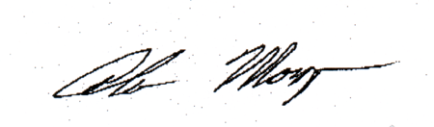

Alan Morgan
Chief Executive Officer
National Rural Health Association

Louis Sanner, MD, personal communication, May 4, 2016
Rural Training Track Technical Assistance Program. http://www.raconline.org/rtt/about_rtts
Candice Chen, MD, et al. Toward Graduate Medical Education (GME) Accountability: Measuring the Outcomes of GME Institutions. Academic Medicine, Vol.88, No. 9. September 2013.
United States Census Bureau. FAQ: How many people reside in urban or rural areas for the 2010 Census? What percentage of the U.S. population is urban or rural? Available at: https://ask.census.gov/faq.php?id=5000&faqId=5971

