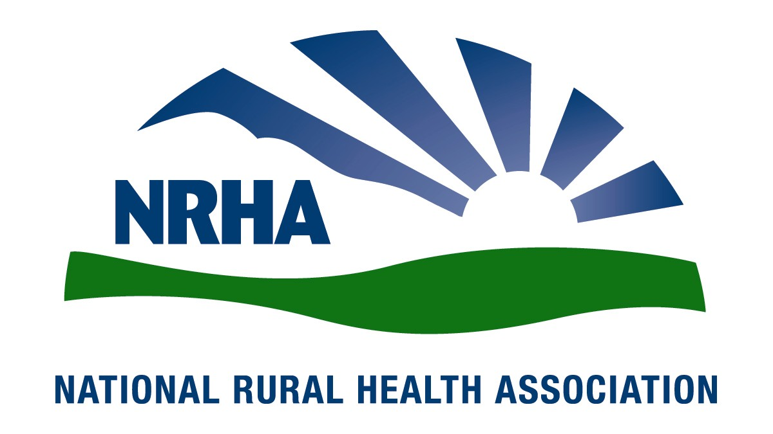
Government Affairs Office
1025 Vermont Avenue
Suite 1100
Washington, D.C. 20005
202-639-0550
Fax: 202-639-0559
Headquarters
4501 College Blvd, #225
Leawood, KS 66211-1921
816-756-3140
Fax: 816-756-3144

January 4, 2016

Andy Slavitt
Acting Administrator
Centers for Medicare and Medicaid Services
Hubert H. Humphrey Building
200 Independence Avenue, SW, Room 445‐G
Washington, DC 20201

RE: RIN 0938-AQ54 - Medicaid Program; Methods for Assuring Access to Covered Medicaid Services

Dear Administrator Slavitt,

The National Rural Health Association (NRHA) is pleased to offer comments on the CMS Final rule and Request for Information for Methods for Assuring Access to Covered Medicaid Services. We appreciate your continued commitment to the needs of the 62 million Americans residing in rural areas, and look forward to our continued collaboration to improve health care access and quality throughout rural America.
The NRHA is a non-profit membership organization with more than 21,000 members nationwide that provides leadership on rural health issues. Our membership includes nearly every component of rural America’s health care infrastructure, including rural community hospitals, critical access hospitals, doctors, nurses and patients. We work to improve rural America’s health needs through government advocacy, communications, education and research.
We appreciate CMS’ continued emphasis on narrowing the gap between rural patients and providers. In collaboration with NRHA policy partners, we look forward to our continued collaboration to ensure access to necessary care for Medicaid beneficiaries living in rural America.
Access to quality, affordable health care is essential for the 62 million Americans living in rural and remote communities. Rural Americans are more likely to be older, sicker and poorer then their urban counterparts. Specifically, they are more likely to suffer with a chronic disease that requires monitoring and follow up care, making convenient, local access to care necessary to ensuring patient compliance with the services that are necessary to reduce the overall cost of care and improve the patients’ outcomes and quality of life. Yet, many rural Americans live in areas with limited health care resources, restricting their available options for care, including primary care.
Rural Medicare beneficiaries face a number of challenges when trying to access health care close to home. Seventy-seven percent of rural counties in the U.S. are Primary Care Health Professional Shortage Areas while nine percent have no physicians at all. Rural seniors are forced to travel significant distances for care, especially specialty services. In an emergency, rural Americans travel twice as far as their urban counterparts to receive care. As a result, while 20% of American live in rural areas, 60% of trauma deaths occur in rural America.

Rural programs and designations, for example the Physician Work Geographic Practice Cost Index and Critical Access Hospitals, are essential to increasing the capacity of the rural health care delivery system to ensure access for rural seniors and make sure these rural safety net providers can fulfill that mission. NRHA urges the Committee to continue its strong support of these important programs.

Rural health care delivery is challenging. Workforce shortages, older and poorer patient populations, geographic barriers, low patient volumes and high uninsured and under-insured populations are just a few of the challenges. Rural physicians and hospitals work around many of these barriers to provide high quality personalized care to their communities. These care givers and hospitals work with a patient population, and their caregivers, that are more likely to be poor and lacking in many of the resources that often lead to better outcomes. Considerations of geography are more than a matter of convenience, as patients may have no means of transportation to allow for care in more distant locations. This is especially true in Medicaid eligible populations.
Medicare and Medicaid – major components of rural health care – pay rural providers less than their urban counterparts. Medicare spends 2.5 percent less on rural beneficiaries than it does on urban beneficiaries. Rural health care providers operate on very thin margins and many rural communities have severe medical workforce shortages. Yet, rural physicians, who put as much time, skill and intensity into their work as their urban counterparts, are reimbursed at lower rates.
Congress has created several rural health payment provisions to improve access to care in rural America. While these programs have been largely successful in maintaining access, considerations of access in rural America are essential within the Medicaid program as well. Ensuring each Medicaid program provides sufficient resources to allow for rural provider participation is essential to the success of each program. Rural Healthy People 2010 highlighted access as the greatest challenge in rural health. Unfortunately, even with existing rural health programs, it remains the number one problem in the updated Rural Health People 2020. More must be done to ensure rural Americans have access to the health care resources necessary to allow them to lead healthy lives.
Programs ensuring sufficient rural payments for hospitals and providers are not ‘bonus’ or ‘special’ payments, but rather alternative, cost-effective and targeted payment formulas that compensate for poorly designed payment schemes that were never meant to be applied to small volume facilities. For example, the Prospective Payment System (PPS) system which closed more than 400 rural, small volume hospitals after its implementation in 1983. These rural payment programs have been able to maintain access to care for millions of rural patients and provide financial stability for thousands of rural providers across the country. Without special attention to the needs of the rural providers that see fewer privately ensured patients that often offset lower payments made on behalf of Medicaid and Medicare patients, rural patients would be forced to travel further for more expensive care. Or worse, these rural Americans would delay essential care because they could not reach the necessary medical providers, resulting in poorer health, a lower quality of life, and more expensive care later. Existing rural payment programs help, but rural access remains a critical problem with potential life and death consequences for rural Americans.

NRHA is particularly concerned about the impact of the rural hospital closures on Medicaid patient access.

Rural health care challenges are well known – from accessing health care services to recruiting and retaining health professionals. Rural communities depend on safety net providers such as Critical Access Hospitals, Community Health Centers, Rural Health Clinics and Federally Qualified Health Centers.

But these important rural access points are facing a closure crisis. Sixty-one rural hospitals have closed since 2010; 283 more are on the brink of closure. Since the start of 2013, more rural hospitals have closed than in the previous 10 years—combined. These closures are a part of a larger trend according to the Cecil G. Sheps Center for Health Services Research at the University of North Carolina, and their numbers show the rate is escalating. Continued cuts in hospital reimbursements have taken their toll, forcing far too many closures and leaving many of our nation’s most vulnerable populations without timely access to care.

If these 283 rural hospitals on the brink to close, then 700,000 patients would lose direct access to care. Already 640 counties across the country are without quick access to an acute-care hospital. Seventy-seven percent of the nation’s 2,041 rural counties are Health Professional Shortage Areas. More than 40 percent of rural patients have to travel 20 or more miles to receive specialty care, compared to 3 percent of metropolitan patients.

Thank you for the chance to offer comments on this proposed rule, and for your consideration on our comments. We very much look forward to continuing our work together to ensure our mutual goal of improving quality of and access to care. If you would like additional information, please contact Diane Calmus at dcalmus@nrharural.org, or 202-639-0550.

Sincerely,
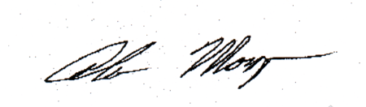

Alan Morgan
Chief Executive Officer
National Rural Health Association

