Z
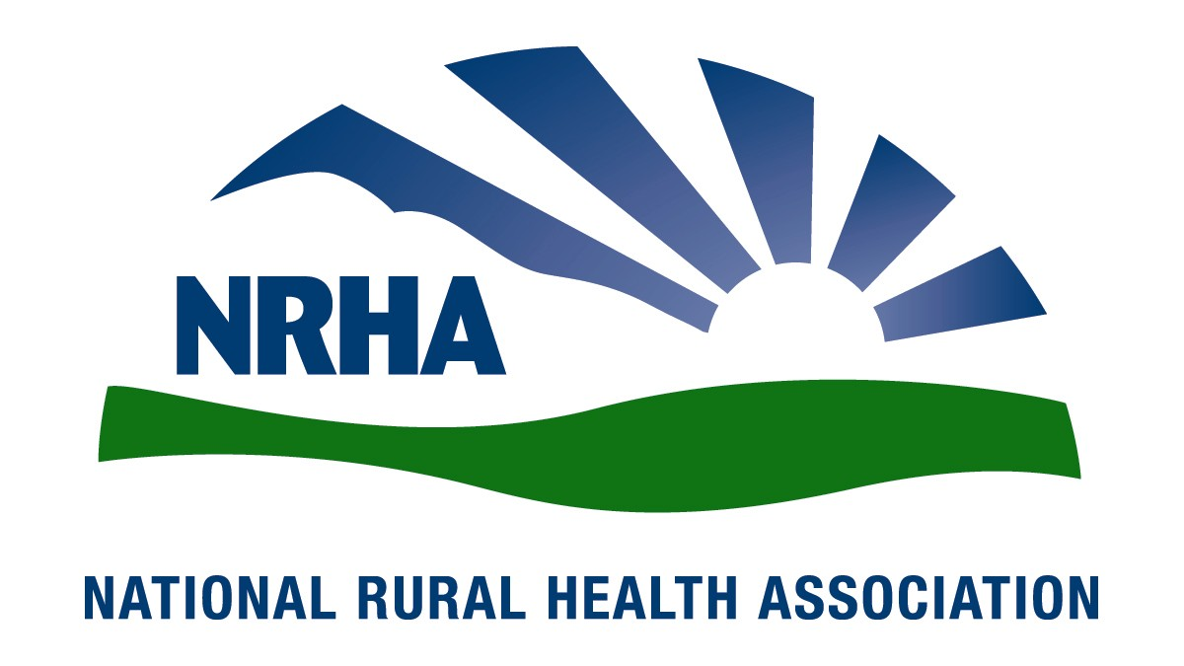
Government Affairs Office
1108 K Street NW
2nd Floor
Washington, D.C. 20005
202-639-0550
Fax: 202-639-0559
Headquarters
4501 College Blvd, #225
Leawood, KS 66211
816-756-3140
Fax: 816-756-3144

February 12, 2015

Kenneth Cohen
Director, Regulation Policy and Management (02REG)
Department of Veterans Affairs
810 Vermont Avenue, NW
Room 1068
Washington, DC 20420

Re: RIN 2900- AP24, Expanded Access to Non-VA Care through the Veterans Choice Program.

Dear Director Cohen,

The National Rural Health Association (NRHA) is pleased to offer comments on the VA interim final rule for the implementation of the Veterans Access, Choice, and Accountability Act of 2014. We appreciate your continued commitment to the needs of the 62 million Americans residing in rural and underserved areas, and look forward to our continued collaboration to improve health care access and quality.

The NRHA is a non-profit membership organization with more than 21,000 members nation-wide that provides leadership on rural health issues. Our membership includes nearly every component of rural America’s health care infrastructure, including rural community hospitals, critical access hospitals, doctors, nurses and patients. We work to improve rural America’s health needs through government advocacy, communications, education and research.

We appreciate the VA’s emphasis on rural veterans and providers. This letter outlines suggestions for which the NRHA believes access to care for rural veterans can be strengthened. We look forward to our continued collaboration in ensuring the one‐quarter of Americans living in rural areas have access to critical health care services in their local communities.

- Distance should be determined based on the care required

NRHA members are most concerned about the inclusion of community based outpatient clinics (CBOCs) when determining whether a veteran is within 40 miles of a VA facility. While CBOCs are an important part of care delivery to rural veterans, these clinics are small, have limited hours, and provide only basic primary care. These outpatient care facilities are not equipped to treat the most common of care needs in rural areas such as pneumonia, severe influenza, injury, cardiac or stroke. While it is appropriate to include these clinics if a veteran requires only primary care services, including these facilities when a veteran requires services not provided at these CBOCs is counter to the clear intent of the law, providing access to care. The interpretation set out in this rule means that rural veterans, many of which are substantially more than 40 miles from a VA hospital, will continue to be without access to necessary care.

Many rural veterans within the 40 mile radius of a provider are substantially further based on road miles, many times substantially further based on a variety of factors including mountainous terrain and frequent inclement weather. While NRHA is pleased by the inclusion of considerations of certain terrain, however, NRHA members are concerned about the implementation of the exceptions to the distance requirement. One rural provider indicated a veteran was only 35 miles from a VA facility, however driving took at least one and a quarter hours due to mountainous terrain and often took substantially longer during frequently inclement weather conditions.

- Rural providers require adequate payments and minimal administrative burden

NRHA applauds the explicit inclusion of rural provides as an important step in providing care to veterans living in rural communities. However, in order for these facilities to see veterans it is important that providing Medicare levels of payments reflect the payments rural facilities receive for seeing a Medicare patient to that end we urge the adopt of langue that makes clear that VA payments utilize Medicare payment methodology including, but not limited to, special payment provisions for critical access hospitals, sole community hospitals, Medicare-dependent hospitals, low-volume hospitals, rural health clinics and federally-qualified health centers. The purpose of these payments is to ensure that rural providers can afford to provide needed care in areas where providers costs are higher and alternative providers are not available. Without these additional payments providers will be limited in their ability to see VA patients that cost more to care for than the provided payment.

Furthermore, while we agree that it is important to ensure that providers and the VA are in agreement on the payment terms and the VA is able to properly ensure that providers have the appropriate credentials to provide the care in question. It is important that the process not be overly burdensome to providers, especially small rural providers. The VA needs to ensure that any contracting requirements and terms are limited to that which is absolutely necessary to ensure proper care and payments.

A particular concern to some NRHA members is the method for submitting the required veteran’s medical record. In light of the VAs substantial efforts to utilize electronic medical records, an option to provide electronic medical records is important and any policy that only allows a hard copy option to provide records without any electronic format option is a regression and represents an unnecessary burden on providers willing to care for veterans. At least one large hospital system indicated the substantial burden of paper records would foreclose the system’s participation in the program. The simple ability to transmit a record in a standard format, such as a pdf, would simplify this requirement and ease the burden on providers.

- Prior Authorization requirement may prevent Veterans from receiving timely care

The clear purpose of the law is to expand access for veterans to care that was not being provided in a timely manner by the VA. We are concerned that the prior authorization requirements set out in the regulation could potentially thwart this purpose. The VA works hard to be responsive in a timely manner to veterans, however, the events that preceded the Veterans Access, Choice, and Accountability Act of 2014 demonstrate that the VA is not always able to live up to its intentions. We are therefore concerned that the requirement that a veteran receive VA approval prior to receiving care could extend the time until the veteran is able to receive actual care. We believe the process requires additional safeguards to ensure veterans and providers receive timely authorization.

Thank you for the chance to offer comments on this proposed rule, and for your consideration on our comments. We very much look forward to continuing our work together to ensure our mutual goal of improving quality of and access to care. If you would like additional information, please contact Diane Calmus at dcalmus@nrharural.org, or 202-639-0550.

Sincerely,

Alan Morgan
Chief Executive Officer
National Rural Health Association

